EE 5356_ DIGITAL IMAGE PROCESSING

PROJECT 12

GEOMETRIC MEAN FILTER

NAME:PAVAI ARCHIMEDES

ST ID: 1001233996

Procedure:

1) For the degraded images given in project#7 Inverse and Wiener Filtering, apply the geometric mean filter for  and show the restored images.

For , GMF is described by Eq. (8.71) /p.291

2) Repeat prob. 1) for 

3) Repeat prob. 1) for 

PROGRAM:

clear all;

close all;

eps = 0.001;

MG = imread('C:\users\PAVAI ARCHIMEDES\Desktop\elaine.512.tiff');

dimension = size(MG);

figure(1);

imshow(MG);

title('Original Image');

MMM = fft2(MG);

F_sh = fftshift(MMM);

H1 = zeros(512);

H2 = zeros(512);

H3 = zeros(512);

Xs = 512;

for vvv = 1:Xs

for q = 1:Xs

H1(vvv,q) = exp(-0.0025*((vvv-Xs/2)^2+(q-Xs/2)^2)^(5/6));

end

end

Xs = 512;

for vvv = 1:Xs

for q = 1:Xs

H2(vvv,q) = exp(-0.001*((vvv-Xs/2)^2+(q-Xs/2)^2)^(5/6));

end

end

Xs = 512;

for vvv = 1:Xs

for q = 1:Xs

H3(vvv,q) = exp(-0.00025*((vvv-Xs/2)^2+(q-Xs/2)^2)^(5/6));

end

end

X = randn(512,512);

X_DFT = fft2(X);

H1_DFT = fft2(H1);

H2_DFT = fft2(H2);

H3_DFT = fft2(H3);

G111 = F_sh.*H1+X;

degraded_image1 = ifft2(ifftshift(G111));

G222 = F_sh.*H2+X;

degraded_image2 = ifft2(ifftshift(G222));

G333 = F_sh.*H3+X;

degraded_image3 = ifft2(ifftshift(G333));

figure(2);

subplot(3,1,1);

imshow(uint8(degraded_image1));

str=sprintf('Deg image K = 0.0025');

title(str);

subplot(3,1,2);

imshow(uint8(degraded_image2));

str=sprintf('deg image K = 0.001');

title(str);

subplot(3,1,3);

imshow(uint8(degraded_image3));

str=sprintf('Deg image K = 0.00025');

title(str);

for vvv = 1:Xs

for q = 1:Xs

if(H1(vvv,q) < eps)

K1(vvv,q) = 0;

else

K1(vvv,q) = 1/H1(vvv,q);

end

end

end

for vvv = 1:Xs

for q = 1:Xs

if(H2(vvv,q) < eps)

K2(vvv,q) = 0;

else

K2(vvv,q) = 1/H2(vvv,q);

end

end

end

for vvv = 1:Xs

for q = 1:Xs

if(H3(vvv,q) < eps)

K3(vvv,q) = 0;

else

K3(vvv,q) = 1/H3(vvv,q);

end

end

end

R = zeros(512);

R = abs(fftshift(ifft2(fft2(MG).*conj(fft2(MG)))))./(512^2);

Rn = zeros(512);

Rn = abs(fftshift(ifft2(fft2(X).*conj(fft2(X)))))./(512^2);

Suu = fftshift(fft2(R));

Snn = fftshift(fft2(Rn));

W1 = ((K1).^0.5).*(Suu.*conj(H1)./(Suu.*(abs(H1).^2)+Snn)).^(1-0.5);

W2 = ((K2).^0.5).*(Suu.*conj(H2)./(Suu.*(abs(H2).^2)+Snn)).^(1-0.5);

W3 = ((K3).^0.5).*(Suu.*conj(H3)./(Suu.*(abs(H3).^2)+Snn)).^(1-0.5);

Fd_1 = G111.*W1;

Fd_2 = G222.*W2;

Fd_3 = G333.*W3;

restored_img1 = ifft2(ifftshift(Fd_1));

restored_img2 = ifft2(ifftshift(Fd_2));

restored_img3 = ifft2(ifftshift(Fd_3));

figure(3);

subplot(3,1,1);

imshow(uint8(restored_img1));

str=sprintf('Res image K = 0.0025, s= 0.5');

title(str);

subplot(3,1,2);

imshow(uint8(restored_img2));

str=sprintf('Res image K = 0.001, s= 0.5');

title(str);

subplot(3,1,3);

imshow(uint8(restored_img3));

str=sprintf('Res image K = 0.00025, s= 0.5');

title(str);

for vvv = 1:Xs

for q = 1:Xs

if(H1(vvv,q) < eps)

K1(vvv,q) = 0;

else

K1(vvv,q) = 1/H1(vvv,q);

end

end

end

for vvv = 1:Xs

for q = 1:Xs

if(H2(vvv,q) < eps)

K2(vvv,q) = 0;

else

K2(vvv,q) = 1/H2(vvv,q);

end

end

end

for vvv = 1:Xs

for q = 1:Xs

if(H3(vvv,q) < eps)

K3(vvv,q) = 0;

else

K3(vvv,q) = 1/H3(vvv,q);

end

end

end

W1 = ((K1).^0.25).*(Suu.*conj(H1)./(Suu.*(abs(H1).^2)+Snn)).^(1-0.25);

W2 = ((K2).^0.25).*(Suu.*conj(H2)./(Suu.*(abs(H2).^2)+Snn)).^(1-0.25);

W3 = ((K3).^0.25).*(Suu.*conj(H3)./(Suu.*(abs(H3).^2)+Snn)).^(1-0.25);

Fd_1 = G111.*W1;

Fd_2 = G222.*W2;

Fd_3 = G333.*W3;

restored_img1 = ifft2(ifftshift(Fd_1));

restored_img2 = ifft2(ifftshift(Fd_2));

restored_img3 = ifft2(ifftshift(Fd_3));

figure(4);

subplot(3,1,1);

imshow(uint8(restored_img1));

str=sprintf('Res image K = 0.0025, s= 0.25');

title(str);

subplot(3,1,2);

imshow(uint8(restored_img2));

str=sprintf('Res image K = 0.001 , s= 0.25');

title(str);

subplot(3,1,3);

imshow(uint8(restored_img3));

str=sprintf('Res image K = 0.00025 , s= 0.25');

title(str);

for vvv = 1:Xs

for q = 1:Xs

if(H1(vvv,q) < eps)

K1(vvv,q) = 0;

else

K1(vvv,q) = 1/H1(vvv,q);

end

end

end

for vvv = 1:Xs

for q = 1:Xs

if(H2(vvv,q) < eps)

K2(vvv,q) = 0;

else

K2(vvv,q) = 1/H2(vvv,q);

end

end

end

for vvv = 1:Xs

for q = 1:Xs

if(H3(vvv,q) < eps)

K3(vvv,q) = 0;

else

K3(vvv,q) = 1/H3(vvv,q);

end

end

end

W1 = ((K1).^0.75).*(Suu.*conj(H1)./(Suu.*(abs(H1).^2)+Snn)).^(1-0.75);

W2 = ((K2).^0.75).*(Suu.*conj(H2)./(Suu.*(abs(H2).^2)+Snn)).^(1-0.75);

W3 = ((K3).^0.75).*(Suu.*conj(H3)./(Suu.*(abs(H3).^2)+Snn)).^(1-0.75);

Fd_1 = G111.*W1;

Fd_2 = G222.*W2;

Fd_3 = G333.*W3;

restored_img1 = ifft2(ifftshift(Fd_1));

restored_img2 = ifft2(ifftshift(Fd_2));

restored_img3 = ifft2(ifftshift(Fd_3));

figure(5);

subplot(3,1,1);

imshow(uint8(restored_img1));

str=sprintf('Rest image K = 0.0025 , s= 0.75');

title(str);

subplot(3,1,2);

imshow(uint8(restored_img2));

str=sprintf('Res image K = 0.001, s= 0.75');

title(str);

subplot(3,1,3);

imshow(uint8(restored_img3));

str=sprintf('Res image K = 0.00025, s= 0.75');

title(str);

RESULTS:

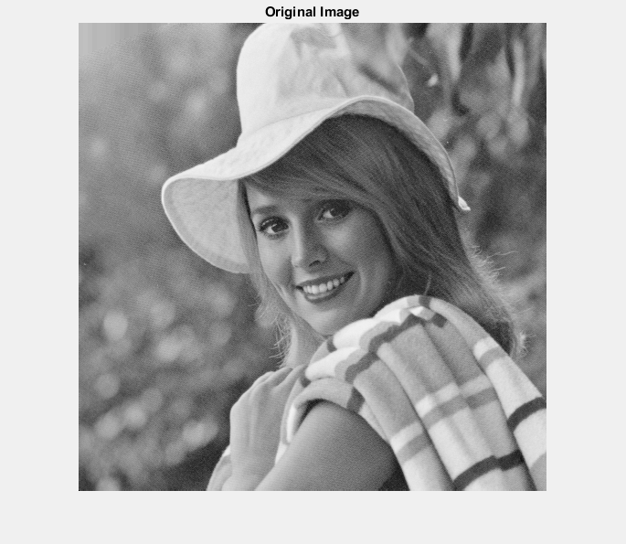

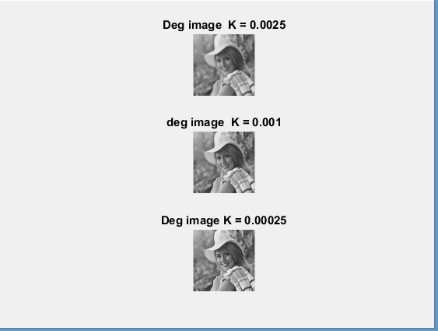

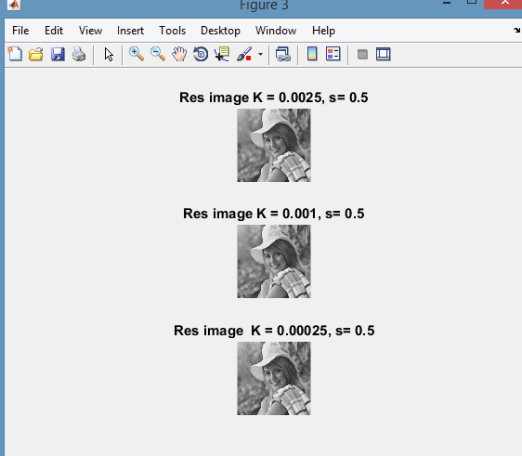

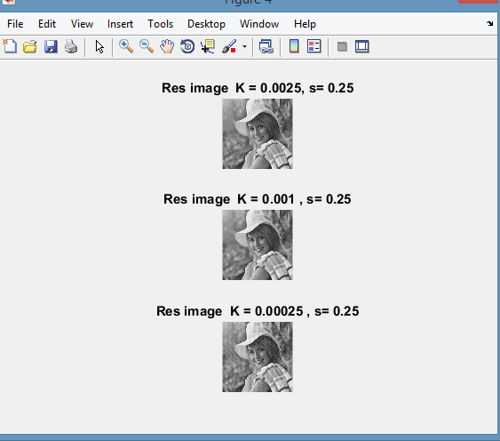

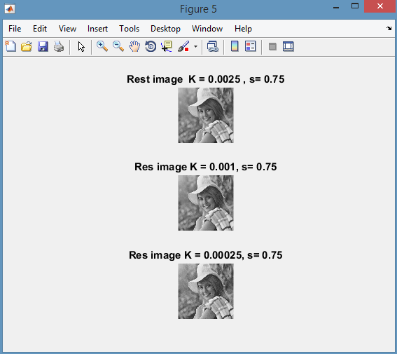

CONCLUSION:

All the steps mentioned in the procedure has been followed and the results are observed